PHASE 1 COMPLETION REPORT

Project: TaskFlow – Smart Personal Task Management System
Phase: Requirement Analysis
Date: 05-Dec-25

Team Members: Farhan Khan, Kamran Khan, Muneeb diyar khan
Supervisor: Shahzad khan

During the Phase 1 of the project, I completed the necessary planning and analysis of the Personal Task Management System. This stage was aimed at understanding what the system should do, how the users will relate with it, and how the data will be stored and handled. I analyzed the whole process of the system and modeled it by diagrams and written specifications.
To begin with, I listed all the features that the system will accommodate, such as user registration, login, creation of tasks, updates, deletion, marking tasks as completed or not, and viewing of tasks. I also designed the sorting, filtering, and searching functions of tasks and a summary on the primary dashboard. These characteristics will render the system helpful to users to operate their daily operations in an easy and systematic manner.
I then wrote the User Flow which is a description of how a user navigates the application, including starting the application, signing up or logging in, using the dashboard, managing tasks, and lastly logging out. I then developed a Use-Case Diagram to indicate all the actions that a user can do in the system. This assisted in picturing the system as the user would see it.
I also created the ERD (Entity Relationship Diagram), The two entities of the system are User and Task, and the relationship between them was well displayed. Lastly, I created the Data Flow Diagrams (DFD) to show the flow of information within the system, including the input of the user and the output of the system to the data storage and data output.
Functional Requirements
- Authentication
- The system must allow users to open an account.
- The system must allow users to use email and password to log in.
- The system must have some way of validating the user input to avoid having goofy data.
- The passwords must be stored in the system in a secure format (hash it, no plain text).
- Task Management
- The system must allow users to make tasks.
- The system must allow users to revise tasks when they have a change of heart.
- The system must allow users to remove tasks that they do not require anymore.
- The system must allow users to indicate that a task is done or not done.
- Task Organization
- The system must allow users to organize tasks according to a category.
- The system must allow users to give priorities to ensure that the urgent ones are highlighted.
- The system must also allow users to create due dates in order to have the deadlines clear.
- Users should be allowed to filter, search or sort tasks to locate what they require.
- Dashboard
- The system is supposed to show the number of:
- Completed tasks
- Pending tasks
- Total tasks
- Today’s tasks
- Responsive Interface
- The system must be compatible with the laptop and mobile browsers.
Non‑Functional Requirements
- Usability
- The system must be extremely user friendly.
- The interface must appear neat and intuitive.
- Performance
- The pages must load fast, nobody likes waiting.
- There should be efficient database operations.
- Security
- Passwords should be kept in a secure manner through hashing.
- Only authorized users are able to see their tasks and not those of everyone.
- Reliability
- The system ought to be able to manage errors.
- Data should not be lost in the normal course of the system.
- Scalability
- New features should be enabled in the system later, such as:
- AI task suggestions
- A mobile app.
  - Case study diagram
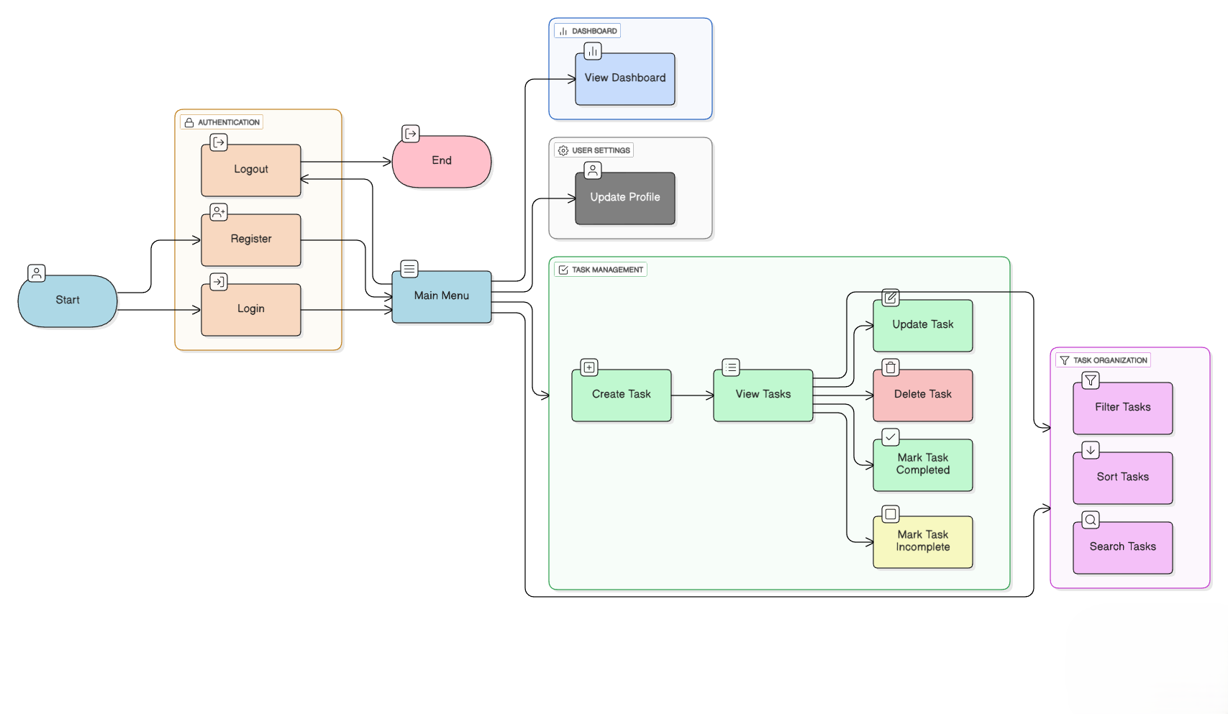
  - ERD diagram
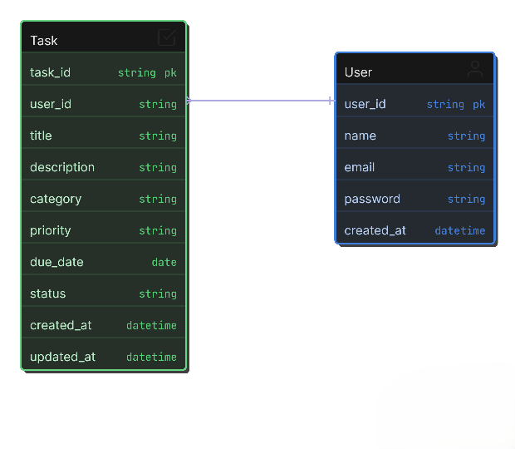

  - DFD diagram
